Terraform statefile: The terraform state file, by default, is named terraform. tfstate and is held in the same directory where terraform is run. It is created after running terraform apply. The actual content of this file is a JSON formatted mapping of the resources defined in the configuration and those that exist in your infrastructure.

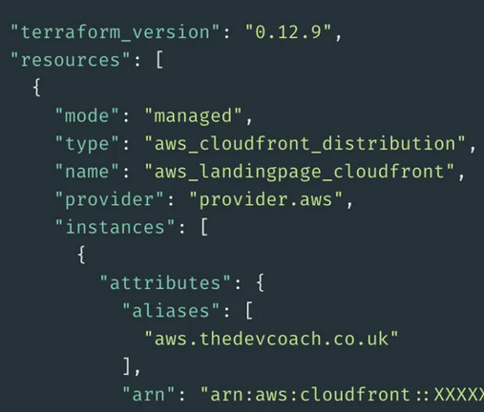

1) Only change terraform statefile by terraform apply command only. Don't manipulate it manually.

How terraform statefile generated: When we run terraform apply command terraform automatically create a statefile which hold all the configuration data.[Locally]

2) Always create a shared remote space for a state file.

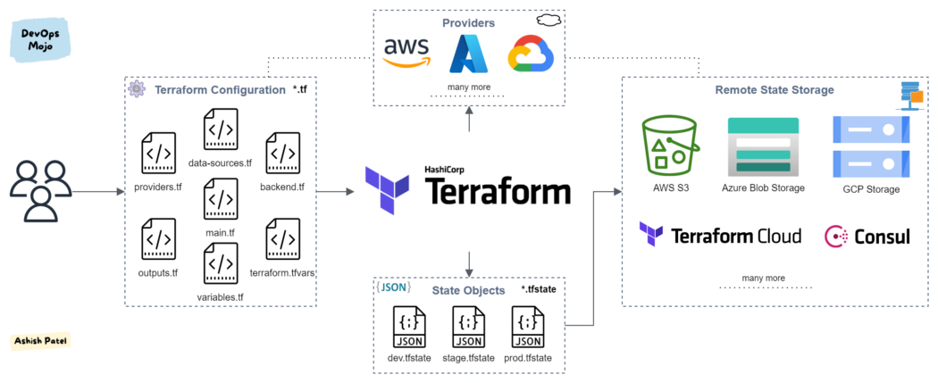

3) Enable locking feature of terraform statefile.

What if you lost statefile is lost or corrupted?

4) Take backup of your statefile. [By enabling versioning of it] > S3 versioning feature

5) Use 1 dedicated statefile per version.

6) Host TF code in Git repository,

7) CI for TF Code.

8) Execute TF only in an automated build.